Russellville Independent Schools EL Lau Plan

Russellville Independent Schools
355 S Summer Street
Russellville, KY 42276

RUSSELLVILLE INDEPENDENT PROVIDES EQUAL EDUCATIONAL AND EMPLOYMENT OPPORTUNITIES

Committee:
Kyle Estes, InterimSuperintendent
Robin Cornelius, Chief Academic Officer
Kenney Hartman, Specialized Instructional Programs Consultant
Ava Quicksall - EL Teacher - Elementary
Griselda Vargas - EL Teacher - Middle School / District Interpreter
Maegan Woodlee - EL Teacher - High School
Irene Vargas - Interpreter
Amanda Collins - Principal
Cameron Kisselbaugh - Classroom Teacher

TABLE OF CONTENTS
LAU DEFINITION---------------------------------------------------------------------------------------------------2
EL STUDENT IDENTIFICATION, ASSESSMENT PROCEDURES, & PLACEMENT PROCESS------------------------------------------------------------------------------------------------------------3
EL COMMITTEE & EL PROGRAM SERVICE PLAN (PSP)--------------------------------------------4
PARENT NOTIFICATION-----------------------------------------------------------------------------------------4
EL PROGRAM OVERVIEW-----------------------------------------------------------------------------------4-5
EL PROFESSIONAL DEVELOPMENT FOR STAFF WHO DELIVER INSTRUCTION or SUPPORT ELs------------------------------------------------------------------------------------------------------5
ANNUAL ENGLISH LANGUAGE PROFICIENCY ASSESSMENT and ADMINISTRATION---6
STATE REQUIRED ASSESSMENTS-----------------------------------------------------------------------6-8
EL STUDENT EXIT CRITERIA and PROCEDURES-----------------------------------------------------8
MONITORING PROCEDURES AFTER STUDENTS EXIT the EL PROGRAM-------------------8
PARENT/FAMILY/COMMUNITY ENGAGEMENT---------------------------------------------------------8
EL PROGRAM EVALUATION----------------------------------------------------------------------------------9
PROCESS TO PROVIDE MEANINGFUL ACCESS TO ALL CO-CURRICULAR AND EXTRACURRICULAR PROGRAMS AND ACTIVITIES--------------------------------------------------9
DEFINITIONS AND ACRONYMS----------------------------------------------------------------------—10-12
EL SERVICES AND ACCOMMODATIONS—————————————————————-13
DOCUMENTS AND TEMPLATES------------------------------------------------------------------------14-27

The district shall have a plan designed to meet the instructional needs of English Learners (ELs) which is referred to as the Lau Plan (Lau v. Nichols, 1974). The plan is designed to meet the district obligations for ELs under Title VI of the Civil Rights Act and the Equal Educational Opportunities Act (EE0A). The purpose of this document is to provide guidance for Russellville Independent Schools in developing, maintaining, and improving our Language Instruction Educational Program (LIEP).

EL STUDENT IDENTIFICATION, ASSESSMENT PROCEDURES, & PLACEMENT PROCESS
Upon registering in the Russellville Independent Schools, administrative staff or attendance clerks provide parents an enrollment packet containing a Home Language Survey (HLS). Then the Home Language Survey form is to be completed by the parents (and or student if of legal age). The HLS is kept in the student’s cumulative folder with a copy in the student’s EL Folder. Parents/guardians will be provided information clearly explaining the purpose and the process. If necessary, an interpreter will be made available to assist families with completion of the forms. Based upon the answers to the first four questions focusing on the identification of languages other than English, the student will then be screened by Russellville Independent School staff.
- What is the language most frequently spoken at home?
- Which language did your child learn when he/she first began to speak?
- What language does your child most frequently speak at home?
- What language do you most frequently speak to your child?

If the parent/guardian answers anything other than English, the staff will perform the WIDA SCREENER Online for grades 1-12. Kindergarten students will be administered the Kindergarten WIDA screener one on one. Once the screener is complete and eligibility is determined (4.5 overall composite), the EL Teacher will meet with the parent, teacher, and chairperson of the committee to determine the Program Service Plan (PSP) within 30 calendar days if the student was enrolled at the beginning of the school year and within two weeks if the student enrolled after the start of the school year. The student will be entered into Infinite Campus as Initially Fully English Proficient (IFEP). If the child is eligible, the team will decide on goals and objectives, EL services, and EL accommodations and secure signatures based on eligibility and placement. The student will take the ACCESS for ELLs 2.0 Online test during the WIDA testing window for Kentucky (usually beginning January through the second week in February). Scores and documentation will be entered into Infinite Campus (IC), and scores entered under the assessment tab in IC. If the student does not qualify for EL services, the scores will be noted in Infinite Campus and parents notified with the student placement in a regular classroom setting and no EL services. The student will not take the ACCESS for ELLs 2.0 Online in January.

A Kindergarten student who has been assessed with the K-WIDA Screener must be enrolled as an EL student and have a Program Service Plan developed regardless of the score. The student will take the ACCESS in January. The student will also be eligible to exit the EL Program if meeting the exit criteria of 4.5 overall. If the student receives an exit score, it will be entered by June 30th of that school year with an exit meeting held with parents by the end of the current school year.

Likewise, all incoming EL students are identified for other programs/status: immigrant, refugee, and migrant. All necessary forms are filled out by parents and sent on to the appropriate district contact. Placement in the appropriate program is monitored by the EL staff and updated in IC as necessary. Students will be identified through the LEP flag tab on the summary screen in IC.

EL COMMITTEE & EL PROGRAM SERVICE PLAN (PSP)
Each student placed in the EL program will have a Program Service Plan (PSP). The EL teacher will develop the PSP and then review the plan with the committee as needed. The committee will consist of the chairperson (principal or designee), a homeroom teacher or a teacher within the team, the EL teacher, and parent ( at high school level, student, if and when permissible). Parent input is always sought in developing the student plan. The EL teacher will determine the appropriate instructional program for each student based on data from either the WIDA Screener or the ACCESS for ELLs 2.0, previous academic experiences and parental input. Students that do not have formal education or previous data in educational records will be placed using screener data, noting chronological age, and will receive the appropriate EL services per the PSP. All original plans and due process will be filed in the student file, with copies being given to the teacher(s), parent, and EL teacher. Parents will be given written notification of the meeting, process, and plans for the student in their native language. Parents will also be given information on their rights to withdraw their child from the program at any time.

PARENT NOTIFICATION
Parents, by law, shall receive written notification of limited English proficient student needs addressing the following:
- Student’s need for placement in the program;
- Student’s level of English proficiency;
- Method of instruction used in the program;
- Student’s lack of progress in the program;
- How the program will meet the individual needs of the student;
- How the program will help the student meet achievement standards necessary for grade promotion and high school graduation;
- Specific exit requirements for students in the program; and
- How the program will help the student learn English

EL PROGRAM OVERVIEW
Each student identified as EL will receive EL instruction based on his/her identified need as specified in his/her EL PSP. EL students will be included in the regular classroom structure as much as possible with the necessary supports as identified on the PSP with accommodations to help ensure the EL student’s success. In addition, the district provides sufficient funds for all EL students to ensure success within the school day. The district uses Title III funds to supplement the program and meets the Title III federal requirements.

Students with limited English proficiency, including immigrant children and youth, refugees, and migrant children shall be provided with access to all programs for which they would otherwise qualify in order to attain English language proficiency, and develop high levels of academic attainment in English, and meet the same challenging student academic content and achievement standards as that of which all children are expected to meet.

Teachers who provide EL instruction shall be fully certified by the Kentucky Department of Education or they shall be enrolled in a university program to pursue such certification. In addition, EL teachers will provide assistance to regular classroom teachers in adapting subject matter instruction for EL students in their classrooms. Regular education modifications may include the use of graphic organizers across the ELP standards, sensory, graphic, and interactive supports, and the use of topics and genres which are content related per WIDA’s ELP Standards. A full list of services and accommodations are located within the documentation section of this plan.

The district coordinator and EL teacher work together to ensure that the LEP extract is run on a monthly basis to locate any errors that might exist within the IC system. The district also updates and verifies any EL data on migrant, immigrant and refugee status.

- Special Education Program
Special Education is a program available to any and all youth when and if the need were to arise, as is with EL students. The Response to Intervention Plan for Russellville Independent will be followed to determine the individual needs of the student. Students that are placed in Tier 2 or Tier 3 will be monitored according to the district plan. The district team will analyze data every 6 weeks to determine if additional support is needed. If an EL student is referred for assessment to determine if he/she were to have a disability and is in need of special education and related services, the principal at the designated school will assign a special education case manager to work with the EL teacher to assure all due process procedural guidelines are met for the student.
- Special Opportunity Programs
All students are universally screened in 3rd grade for creativity and academic giftedness. Students that show high potential are further evaluated for identification areas. Local norms are also used to place students in enrichment programs and GT services. If our EL students require testing accommodations, those are provided to the student during GT testing.

EL PROFESSIONAL DEVELOPMENT FOR STAFF WHO DELIVER INSTRUCTION or SUPPORT ELs
EL teachers, regular classroom teachers, and administrators will participate in ongoing professional development to address the instructional strategies needed to assist EL students thus ensuring quality educational programming for ELs. PSP’s and accommodations training are also discussed with EL teachers, and regular classroom teachers so that they all work together cooperatively to make plans for students. Russellville Independent Schools has a teacher handbook on ELs that it makes available to teachers and periodically reviews in PD sessions due to teacher turnover. Copies or originals of the materials used, sign off sheets, and documentation from the training will reside with the district administrator for EL services.

In addition, each summer, the DPP/ district DPP administrative assistant meets with all attendance clerks, school counselors, and administrative assistants that deal with enrollment and Infinite Campus data entry and provide regular updates, and training on EL and immigrant rights. They are also trained on the Home Language Survey and how to help parents. They are made aware that the EL teacher, EL district coordinator and school counselor or assistant principal (the administrator in charge of EL folders within each set building) is to be contacted in case a family may be in need of a translator to complete forms.

Teachers are given opportunities for further professional development including GRREC training, and Kentucky Teaching English to Speakers of Other Languages (KYTESOL).

ANNUAL ENGLISH LANGUAGE PROFICIENCY ASSESSMENT and ADMINISTRATION
Students identified as EL will take the annual assessment offered in the state of KY during the months of January and early February. Students will be tested using the ACCESS for ELL’s 2.0 online assessment for grades 1-12. Kindergarten students will still be given the ACCESS for Kindergarten on an individual one-to-one basis with the test administrator. Students in grades 1-3will use writing booklets for the written section of the test, and 4-12 will use the computer key pad for recording their results on the written portion of the test. Students that qualify for the Alternate Assessment (English Learner Student with Disability, ELSWD), as per KY Alternate Assessment Guidelines, will be given the Alternate Access for ELL’s. All test materials will be received by the DAC and secured until testing. Testing tickets will be printed and secured until testing begins. The Building Assessment Coordinator (BAC) will secure testing materials once the testing window opens. Materials will be returned to the District Assessment Coordinator (DAC) once all testing for a particular grade level or school is completed. The DAC will send all information from testing to the DRC for scoring. Scores will be received the third week of April for the State of KY.

Each test administrator will complete online training through the WIDA portal addressing the ACCESS test and the use of the DRC portal---WIDA Assessment Management System (WIDA AMS). EL teachers will also attend district training on accommodations and inclusion training per district guidelines. All trainings will be completed per the designated test given, i.e. Alternate ACCESS, ACCESS Online, or ACCESS Kindergarten Level. Passing scores must be achieved and certificates sent to the District Curriculum and Testing Coordinator. EL teachers will work together to ensure a viable test schedule is outlined and delivered to district and building administrators. All attempts will be made to secure adequate testing sites clear of distractions. Building principals will be made aware of dates to clear the calendar of any pre scheduled drills, bus evacuations, etc.

STATE REQUIRED ASSESSMENTS
All ELs must participate in:
In accordance with 703 KAR 5:070 and the document entitled Inclusion of Special Population and in the State Required Assessment and Accountability Program, each school shall assess all EL students enrolled on the first day of the testing window in all parts of the state required assessment unless the students are in the first year of enrollment in a United States School.
All ELs must participate in :
- The state approved English language proficiency assessment annually. Regardless of time enrolled in a U.S. school, all ELs enrolled in grades K-12 shall participate.
- All state-required assessments after one full year of enrollment. The first full year of enrollment is defined as 240 days or 12 months. These are cumulative.
- A mathematics test for participation only (if a student is enrolled in a grade in which a mathematics test is administered) for first year EL students with appropriate accommodations noted in the EL’s Program Service Plan (PSP).
- A science test for participation only (if a student is enrolled in a grade in which a science test is administered) for first year EL students with appropriate accommodations noted in the EL’s PSP.
Exemptions:
ELs in their first year of enrollment in a U.S. school are not required to participate in the state-required reading, social studies or writing (language mechanics and on-demand) assessments. For these students, these assessments are optional and at the discretion of the school and district. This is a one-time exemption.

If a student is unable to test due to health reasons, then the district will follow the medical exemption procedures as per Kentucky Department of Education guidelines.

Administration of accommodations for state testing:
For EL students who have been identified, it may be necessary to permit instructionally consistent accommodations for the assessment administration. Any accommodation shall be based on an assessment of English language proficiency, consistent with the ongoing delivery of instructional services, and stated in the student’s PSP. Accommodations shall not be solely for the state-required assessment. Implementation of any accommodations shall not impact the content being measured.

For all EL students, PSP committees shall determine on an individual basis whether these students will participate with or without accommodations in the state-required Assessment and Accountability Programs. An EL student may use accommodations in the state-required assessments if the student meets all of the following criteria:
- Has been assessed with an English language proficiency assessment and meets the criteria as an EL student;
- Has evaluation data that demonstrates a need for accommodations;
- Has a current PSP developed by the PSP committee that includes accommodations as part of the student’s ongoing delivery of instruction; and
- Is participating in instructional programs and services to meet the language and academic content needs of the student.
These accommodations shall be related to the individual student’s needs and the impact of the student’s English language proficiency on demonstrating what the student knows on a test written in English and the ability to access the curriculum. These decisions shall be made in the best interest of the student (e.g., scribing for a student throughout the school year just so that a scribe can be provided for assessment is not in the student’s best interest versus providing a bilingual dictionary with extended time).

If accommodations are needed, documentation shall include:
- The name and date of the English language proficiency assessment administered to determine a student’s EL status;
- A PSP that includes the specific accommodations to be implemented in instruction;
- A list of the names of the PSP committee members who reviewed the documentation and made the decisions. The list of staff shall be placed with the Title III records;
- The appropriate accommodations needed; and
- The signature of the principal of the appropriate school as an indication of approval for the described accommodations.

The EL student’s performance on the annual English language proficiency assessment in conjunction with professional judgment shall determine when accommodations are no longer required. Implementation of any accommodations shall not impact the content being measured.

EL STUDENT EXIT CRITERIA and PROCEDURES
In order to exit from the EL program, a student must achieve a proficiency score of 4.5 or higher in the Overall (Composite) Level on a Tier B or a Tier C ACCESS for ELLS 2.0 in the Kindergarten or above. Students cannot exit based on a Tier A result. The Program Exit Date will be recorded as. June 30th of the year he/ she exists. An EL committee meeting will be held to discuss the student’s ACCESS for ELL’s 2.0 scores. The committee will consist of the chairperson (principal or designee), a homeroom teacher or a teacher within the team, the EL teacher, and parent and student (high school level, if and when permissible). The EL Exit form will be filled out and signed by all members of the committee. The Post Monitoring will also be filled out so that it can be used for the next school year. In addition, the LEP flag tab in IC will be end dated. Accommodations will be discussed and updated per student need. ALL documentation will be placed in IC per state rollover, and all student roster test sheets will be filed in the student EL folder and data entered onto the Assessment Data form in IC. All folders will be checked each year, with EL teachers or building administrators checking folders before progressing to the next school.

MONITORING PROCEDURES AFTER STUDENTS EXIT the EL PROGRAM
Students that have achieved the proficiency score of 4.5 on overall will qualify to exit the EL program. Students will then be eligible to participate in the monitoring process with the use of classroom accommodations for the next four (4) years. No accommodations will be given during testing. After the student has been exited and the Post Monitoring form has been filled out in IC, the principal (or designee) will make sure that all teachers that work with the student have access to the form for ongoing documentation (or may make a copy of the form to use throughout the year, with the teacher giving the administrator the form to upload to IC each quarter or trimester), thus keeping apprised as to the student’s needs. Teachers will also have a copy of the student’s accommodations list to use in the classroom. The goal being to update and discuss often the needs of the student and to slowly remove accommodations as the student becomes a stronger more confident English Learner within the classroom setting. If a student is not being successful within the classroom setting, it is the job of all educators, teachers, and parents to note the student’s weaknesses, struggles, and reassess his/her EL situation and where he/she might need to be pulled back into the EL program. That is why ongoing documentation is vital for student success.

PARENT/FAMILY/COMMUNITY ENGAGEMENT
Ongoing parent involvement is crucial for a successful EL program and student success. EL teachers are encouraged to contact parents with positive updates, awards students may receive, and concerns he/she may have about a student. In addition, throughout the school year, the EL teacher at designated buildings will work with the curriculum coordinators and other office staff to develop programs to present to parents (i.e. KPREP test scores, TITLE I Night/information, and Parent/Teacher Conferences). Meeting notices, agendas, sign-in sheets, minutes, questionnaires/surveys or other relevant documents will be gathered and sent to the district EL coordinator.

EL PROGRAM EVALUATION
The EL coordinator at the district level will assess progress data (such as KPREP, STAR reading and math, ACCESS, and current grades) drop out rates, graduation rates, and retention rates for current and former EL students. The EL coordinator will also review transition data compiled by Russellville Independent High School administrators to assess whether current and former EL students are making a successful transition to adult life. The coordinator will review the extent to which current and former EL students participate successfully in each school’s curriculum including achievement, honor awards, extracurricular activities, gifted and talented education, and special education placement. Additionally, the coordinator will monitor EL programs in all schools to ensure that students are entering and exiting the program according to district procedural guidelines and monitor the process of the EL program and when/if necessary meet with teachers/staff to make revisions. If the EL coordinator discovers discrepancies in the EL program effectiveness at a set school, within 30 days the EL coordinator will meet with the EL teacher and principal to develop a corrective action plan.
PROCESS TO PROVIDE MEANINGFUL ACCESS TO ALL CO-CURRICULAR AND EXTRACURRICULAR PROGRAMS AND ACTIVITIES

All EL students will have meaningful access to the core curriculum (e.g. reading/language arts, math, science, and social studies) to ensure success in general education classrooms. Russellville Independent Schools will provide programs that enable EL students to attain English proficiency as well as provide support in other curricular areas that will provide ELs with equal opportunities to participate in the curriculum.
- EL programs will provide access to the same standard grade-level curriculum
- ELs are integrated into the school’s educational programs and extracurricular offerings
- ELs have equal access to all school facilities (e.f., computer labs, cafeteria, gym, library)
- Content assessments will be analyzed to indicate if ELs are making academic progress while in the EL program.
- When given an IQ assessment or academic screener (excluding the WIDA Screener) ELs will have access to all accommodations and/or tests written in their native language.

DEFINITIONS AND ACRONYMS
Common terminology and acronyms

ACCESS for ELLs 2.0 - secure large-scale online English Language proficiency assessment administered to 1st through 12th grade students who have been identified as English language learners (ELLs) annually. (The ACCESS paper test is still administered to Kindergarten students.)
Content Area Tutoring - Programs that provide one-on-one or small group tutoring/assistance to ELLs during school hours in the content areas, including English language arts, mathematics, science, and social studies. Tutoring is generally provided by teachers other than bilingual or ESL teachers and may be provided by an aide under the direction of a teacher.
Content-based English as a Second Language - This approach makes use of instructional materials, learning tasks, and classroom techniques from academic content areas as the vehicle for developing language, content, cognitive and study skills. English is used as the medium of instruction.
Dual Language Program - Also known as Two-way Immersion or Developmental Bilingual Education, the goal of these bilingual programs is for students to develop language proficiency in two languages by receiving instruction in English and another language in a classroom that is usually comprised of half native English speakers and half native speakers of the other language.

DRC - Data Recognition Corporation works in conjunction with WIDA-AMS
EL - English Learner

English as a Second Language (ESL) - ESL is an educational approach in which English language learners are instructed in the use of the English language. Their instruction is based on a special curriculum that typically involves little or no use of the native languages, focuses on language, (as opposed to content) and is usually taught during specific school periods. Fort the rest of the school day, students may be placed in mainstream classrooms, an immersion program, or a bilingual education program.
English Language Development (ELD) - English language development (ELD) means instruction designed specifically for English language learners to develop their listening, speaking, reading, and writing skills in English. This type of instruction is also known as English as a Second Language (ESL), Teaching English to Speakers of Other Languages (TESOL), or English for Speakers of Other Languages (ESOL).
ELL - English Language Learner
ELP - English Language Proficiency
ELSWD - English Learner Students with Disabilities

GRREC - Green River Region Educational Co-op

HLS - Home Language Survey
IFEP - Initially Fully English Proficient
KYTESOL - Kentucky Teachers of English Speakers of Other Languages

LEP - Limited English Proficient; term used under NCLB; replaced with English Learner (EL) in Every Student Succeeds Act (ESSA); English Language Learners (ELL), is also acceptable replacement term for LEP

LIEP - Language Instruction Educational Program
PSP - Program Service Plan
Pull-out ESL/Resource - Programs remove ELLs from general education classes to pre-teach, teach, or re-teach English language skills and/or academic content covered by the general education classroom teacher.
RFEP - Redesignated Fully English Proficient
Sheltered English Instruction - An instructional approach used to make academic instruction in English understandable to ELL students. In the sheltered classroom, teachers use physical activities, visual aides, and the environment to teach vocabulary.
Structured English Immersion Program - The goal of this program is acquisition of English language skills so that the ELL student can succeed in an English-only mainstream classroom. All instruction in an immersion strategy program is English. Teachers have specialized training in meeting the needs of ELL students, possessing either a bilingual education or ESL teaching credential and/or training, and strong receptive skills in the students’ primary language.
Submersion Program - A submersion program places ELL students in a regular English-only program with little or no support services on the theory that they will pick up English naturally. This program should not be confused with a structured English Immersion program.
Transitional Bilingual Education Program - This program, also known as Early-exit Bilingual Education, utilizes a students’ primary language in instruction. The program maintains and develops skills in the primary language and culture while introducing, maintaining, and developing skills in English. The primary purpose of a TBE program is to facilitate the ELL student’s transition to an all-English instructional program while receiving academic subject instruction in the native language to the extent necessary.

W-APT - WIDA-ACCESS Placement Test
WIDA - stopped using the acronym definition of World-Class Instructional Design and Assessment Consortium and is now just WIDA. It is a non-profit cooperative group whose mission is to advance academic language development and academic achievement for children and youth who are culturally and linguistically diverse through high quality standards, assessments, and professional learning for educators.
WIDA-AMS - WIDA Assessment Management System
WIDA Screener Online (WIDA Screener) - is an English language proficiency screener test given to incoming students in Grades 1-12 to determine whether they qualify for English language support services. WIDA is working with Data Recognition Corporation (DRC), the technology and test platform development partner, to deliver the assessment to all testing sites.

EL SERVICES:
CAT: Content Area Tutoring
CBE: Content Based ESL
DBE: Developmental Bilingual Education
HLA: Heritage Language
POE: Pull-Out ESL Resource
SEI: Sheltered English Instruction
SEN: Sheltered English Immersion
TBE: Transitional Bilingual Education
TWI: Two-Way Immersion

EL ACCOMMODATIONS:
Instructional: Instructional: (Continued)
RDR: Reader MC: Model Language and Task Completion
SB: Scribe Responses LO: Provide Language Objectives
BED: Bilingual or English Dictionary IO: Interaction Opportunities
PC: Prompting and Cueing ML: Model Language and Task Completion
VO: Provide Visuals/Organizers RDR: Reader
SP: Use Spell Check
CO: Provide Content Objectives
AC: Engage in Academic Language Assessment:
MC: Meta-Cognitive Strategies BED: Bilingual/English Dictionary
ONLS: Oral Native Language Support ONLS: Oral Native Language Support
RPT: Read Text in Primary Language ET: Extended Time
ET: Extended Time SB: Use of Scribe
SGSF: Small Group/Single Form Test. SL: Simplified Language
AMT: Adapted Materials/Technology BEG: Bilingual or English Glossary
PL: Link Instruction to Prior Learning RDR: Reader
BK: Build Background Knowledge
SR: Scaffold Responses
BEG: Bilingual or English Glossary
SL: Simplified Language
AT: Assistive Technology
AP: Adapt Pace of Instruction
CS: Use Computer/Software

DOCUMENTS AND TEMPLATES
See attachments:
May 1, 2021

Dear Parent/Guardian of (student’s name),
Enclosed is a report of your child’s English language proficiency scores from an assessment that was administered this past January. The report details your child’s English language skills in the area of listening, speaking, reading and writing, a literacy score, a comprehension score (listening and reading scores combined) and an overall score. The assessment, called ACCESS for ELLs® (Assessing Comprehension and Communication in English from State to State for English Language Learners) is used throughout Kentucky and in other states. This report identifies (student’s name) language skills in both social and academic English. Social language is used to communicate for everyday purposes. Academic language is used to communicate in the content of language arts, mathematics, science and social studies. Information on English language proficiency levels are also given at the bottom of the report. Below is an explanation of the levels of Language Proficiency (scale of 1-6) that are used in the Russellville Independent School District, and is reflected on the enclosed report. Your child’s report will be discussed next school year at his/her annual EL meeting within the first 30 days of school.
English Language Proficiency Levels (grades K-12):
Level 1 (Entering): The student knows and uses minimal social language and minimal academic language with visual support.
Level 2 (Beginning): The student knows and uses some social English and general academic language with visual support.
Level 3 (Developing): The student knows and uses social English and some specific academic language with visual support.
Level 4 (Expanding): The student knows and uses social English and some technical academic language.
Level 5 (Bridging): The student knows and uses social and academic language working with grade level material.
Level 6 (Reaching): The student knows and uses social and academic language at the highest level measured by this test.
To exit from the ELL (English Language Learner) program, ELL students will have reached the minimum level of a 4.5 on a Tier B or C.
Parents also have the right to decline to have a child enrolled in the EL program. Upon your request, your child will be immediately removed from receiving services for EL, however, your child must take the annual proficiency exam (ACCESS for ELL’s in January).
Based on the results of this English language proficiency assessment and according to the proficiency levels displayed on the enclosed report, your child is qualified to continue to receive EL services.
Please contact me if you have questions regarding this report. More information about this assessment can be found at www.wida.us.
Sincerely,

El Teacher, Russellville Independent School

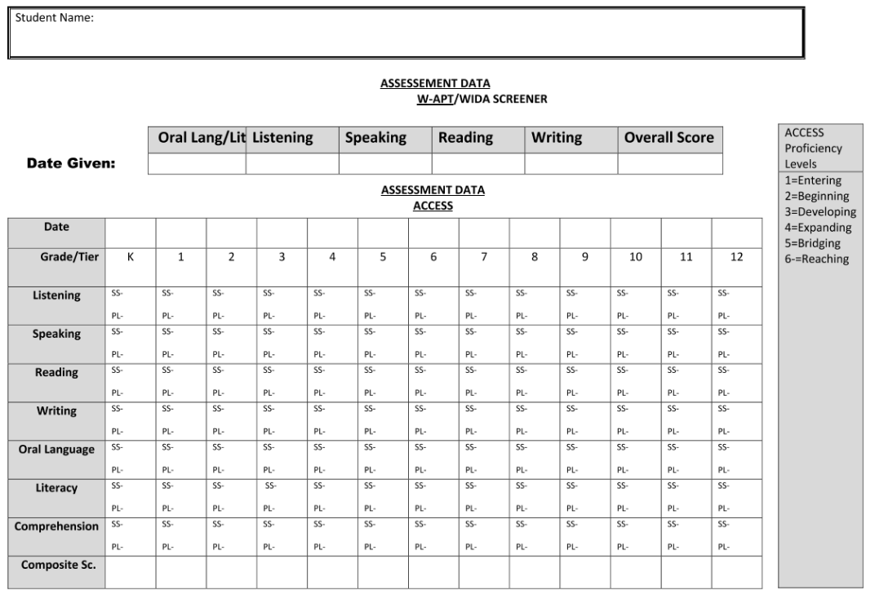

Russellville Independent Schools
English Learner Program
Exit Letter

Name of Student: ______________________________________ Date: ____________________
School: __________________________ Homeroom Teacher:_____________________
Student ID #: ___________________________
Dear Parent (guardian),
The annual ACCESS for ELLs 2.0 was administered in January of this year. Those results are in and show that your child has made a significant improvement in his/her ability to listen, speak, read, and write in English. Your child has received an ACCESS for ELLs 2.0 score of 4.5 composite/overall score. As a result of your child’s improved English Language Proficiency, he/she no longer qualifies for services provided by the Russellville Independent School District’s English Learner Program. Attached is your child’s Individual Student Report, please feel free to contact us if you have any questions about your child’s results if you are not able to attend our exit meeting.
Sincerely,
_______________________________ ________________________________
Chairperson/Title School Phone

Conference Summary Notes:

________________________________ _____________________________
Signature Title

________________________________ _____________________________
Signature Title

________________________________ ______________________________
Signature Title

________________________________ ______________________________
Signature Title

________________________________ ______________________________
Signature Title

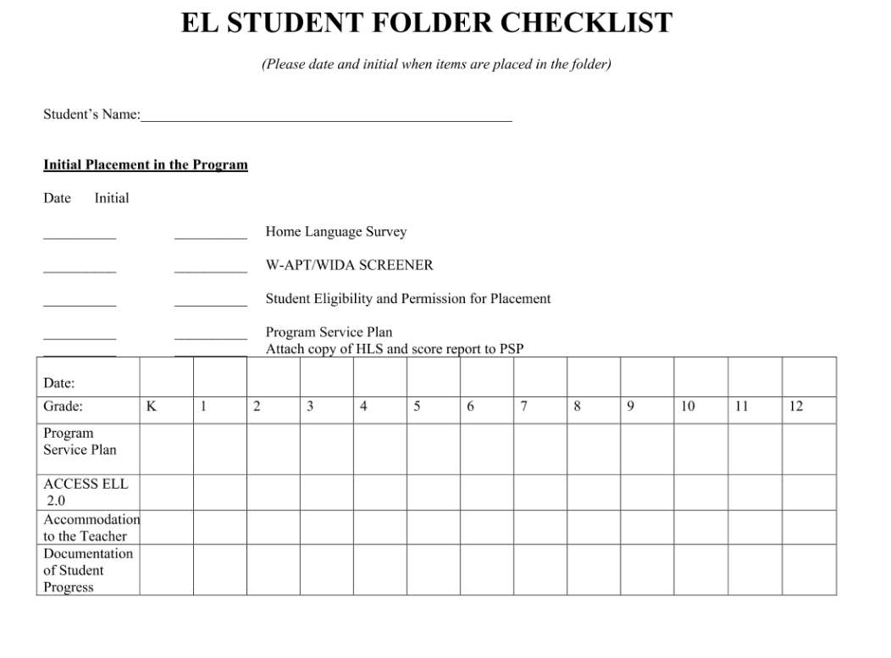

Dear Parent/Guardian:

Home Language Survey

The purpose of the home language survey (HLS) is to determine the primary or home language of the student.
This information is essential in order for schools to provide meaningful instruction for all students. The HLS is
part of the statewide identification process required under Section 3113(b)(2) of the Every Student Succeeds Act
(ESSA) and 703 KAR 5:070 and the related Inclusion of Special Populations Guidance.

The HLS must be given to all students in grades K-12 upon their initial enrollment in the district as a first
screening process to identify potential English learner students. The HLS is administered one time, upon initial
enrollment in grades K-12 and remains in the student’s cumulative file.

Please note that the answers to the survey below are student-specific. If a language other than English is
recorded for ANY of the required survey questions below, the district is legally obligated to do further
assessment of your child to determine if they are eligible for language support.

Answers will not be used for determining legal status or for immigration purposes. If your child is identified for
English language services, you may decline some or all of the services offered to your child.

If you have any questions on how to complete the HLS, please contact your child’s school.

Student Information (required):
Name: Grade:
Student Language Background (required):
1. What is the language most frequently spoken at home?
2. Which language did your child learn when they first began to talk?
3. What language does your child most frequently speak at home?
4. What language do you most frequently speak to your child?
Language for School Communication (not required):
5. In which language would you prefer to receive all school information:

Parent/Guardian Signature: Date:

By signing here, you certify that responses to the four required questions above are specific to your student. You
understand that if a language other than English has been identified, your student will be tested to determine if they qualify for language support services, to help them become fluent in English. Students qualifying for language support services are entitled to services as an English learner and will be tested annually to determine their English language proficiency as required by ESSA 1111(b)(2)(G).

For School Use Only

School personnel who administered and explained the HLS and potential placement of a student into an English
language development program if a language other than English was indicated:

Name / Date:

Revised 11/2019

Russellville Independent Schools
Waiver/Refusal of English as a Second Language Program

Date: ____________________

Dear Parent or Guardian:

Your child, ______________________________________________has been identified as being eligible for an English as a Second language program. This determination is based on an assessment of your child’s ability to understand, speak, read, and write English.

If you do not agree with this determination or do not want your child in this program, please sign the waiver notice below and return it to the school. If you have any questions, please feel free to contact me at via one of the following:

270-726-8405
kenney.hartman@russellville.kyschools.us

Sincerely,

_____________________________________

Program Designee

Russellville Independent Schools
Waiver/Refusal of English as a Second Language Program

Dear Program Designee: ___________________________________

I do not want my child ________________________________________, to be placed in the English as a Second Language program. I have been informed that my child will still have to take the ACCESS test each year until he/she scores a 4.5 on the test. I understand that by signing this form, my child will not receive services from the ELL teacher and will not receive EL accommodations on standardized tests.

Name of the Parent/Guardian: ________________________ Date: __________

Signature: ____________________________ Phone number: ______________

Russellville Independent Schools
Monitoring English Learners
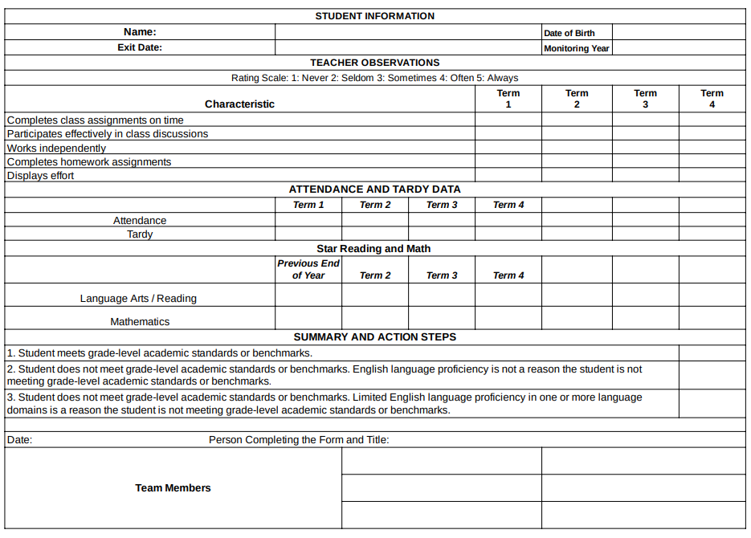

Please attach any additional documents or pertinent information.

Page 1 of 3
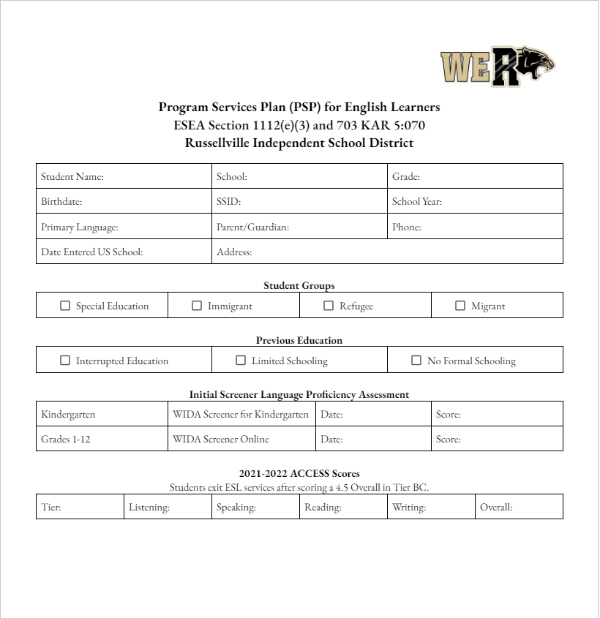

Page 2 of 3
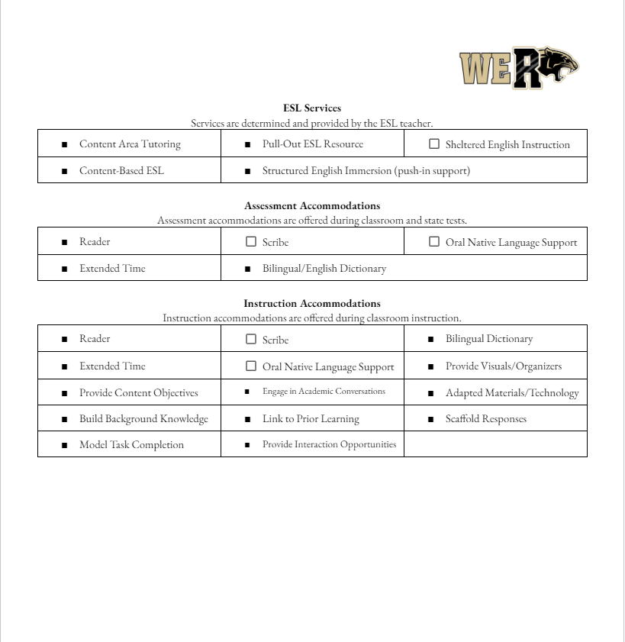

Page 3 of 3

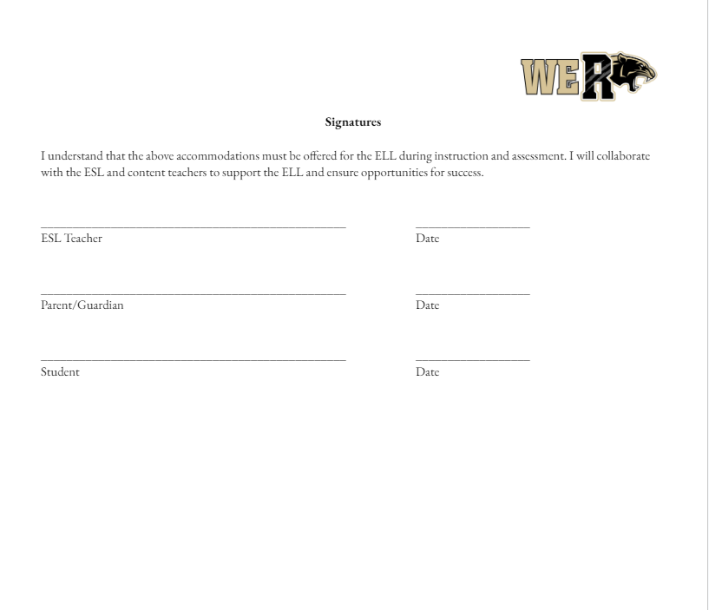

Russellville Jr/Sr High School
“A Tradition of Excellence”
1101 West Ninth Street
Russellville, Kentucky 42276
Phone (270) 726-8421
Fax (270) 726-3685

Rex Booth Tracy Naylor Juli Link
High School Principal Assistant Principal Guidance Counselor

Parents and guardians,
In _________ your child participated in the annual language proficiency assessment, WIDA ACCESS. Your child achieved a score of 4.5 or higher to exit the English as a Second Language (ESL) program. On behalf of everyone at Russellville Independent schools, thank you for allowing your child to participate in the program and supporting us in your child’s education. We want to congratulate you and your son/daughter on their successful exiting of the ESL program. We will have a ceremony to recognize your student on day of the week, Month and date at time in the Russellville High School Auditorium. We encourage you and your family to join us in celebrating your student’s achievement.
Teacher:

